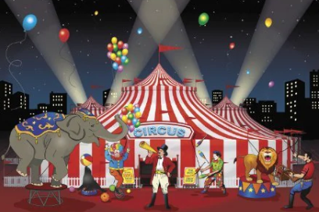
Garden Class – Summer 1
The Greatest Show - Homework Tasks

Science: Plants
Take a trip to a garden centre and look at all the different types of plants and trees.
Buy a packet of seeds with your pocket money and plant them in a pot. Look after it and take some photos.
Science: Materials
As one of your jobs for 20p, start to wash, squash and recycle materials from your home.
What colour is your recycling bin?
Design and Technology:  Can you make a circus big top tent and/or a puppet theatre and put on a show? | PSHE: Money Matters  Start to do some jobs at home for 20p a job, to earn some pocket money.  Then save your money in a piggy bank/bank account and add up how much you have earnt and saved this term. | History: Nurturing Nurses  Research Florence Nightingale.  What is her connection to Derby?  Challenge – can you find the Florence Nightingale statue in Derby and have a photo taken and bring it into school for show and tell?

